**Code review - ListComponent.tsx**

**The code was reviewed by Tomer Shor - 325511541**

**Areas for Improvement**

1. **Improve Code Readability**

1. Rename functions and variables to make their purpose clearer. For example, the function that retrieves a random item should specify that it only selects incomplete items. That means – changing the function“getRandomItem” to “getRandomIncompleteItem”.

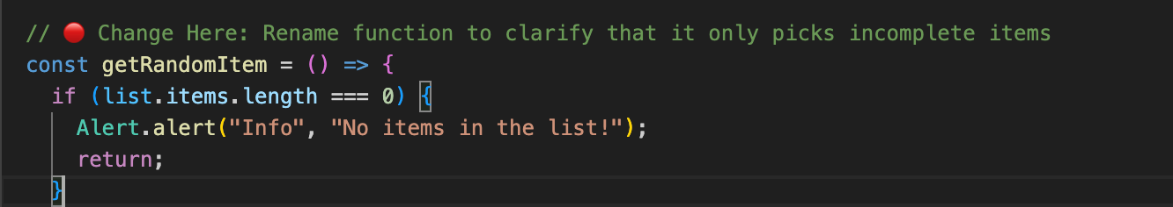

b. Lack of documentation is very present in this code. I would suggest adding notes next to each move, especially next to untrivial functions.

**2️. Reduce Code Duplication**

-Extract repetitive logic into reusable helper functions. This will improve maintainability and make updates easier.

--Common operations such as updating the list and progress should be handled in a single function instead of being repeated across multiple actions.

**3️. Fix State Mutation Issues**

• Avoid modifying state variables directly. Instead, use immutable updates to ensure data integrity and prevent unexpected bugs.

• Functions modifying the list, such as marking an item as completed or deleting an item, should return a new state rather than altering the existing one. This way, the program could prevent some unexpected errors.

